School of Information and Communication Technology
Griffith University

Course code: 7821ICT – WIL Single Project

Interfaces for Sugarcane Planting AI System

Project Proposal
Team Name: NA_705 – Sugarcane AI
Date of Submission: 16/Apr/2021/T1
Industry Partner: Griffith University | School of Engineering and Built Environment
Client: Andrew Busch

Team members:
Team member 1: Ben Li
Team member 2: Aiqi Liu
Team member 3: Johnson Taylor
Team member 4: Singithi Lekamlage


Revision History

Date | Version | Author(s) | Comments
24/Mar | 0.1 | Ben Li | Detailed requirements from client meeting
27/Mar | 0.2 | Aiqi Liu | Add team role
31/Mar | 1.0 | Ben Li | First edition of complete version
13/Apr | 2.0 | Ben Li | First submit version of completed proposal
15/Apr | 2.1 | Ben Li | Add project plan section
Table -1

Table of Contents

1. Introduction 6
1.1. Project Overview 6
1.2. Team Overview 6
1.3. Definitions and Acronyms 6

2. Project vision 6

2.1 Product Vision 6

2.2 Customers and Benefits 6

2.3 Key Factors to Judge Quality 7

2.4 Key Features and Technology 7

2.5 Other product factors 7

3. Project Organisation 7

3.1 Organisational Structure 7

3.2 Project Responsibilities 7

3.3 Identification of Skill Needs 7

3.4 Satisfaction of Skill Needs 8

3.5 Success criteria 8

3.6 standards for work products 8

3.7 RISK Management 8

Introduction

Project Overview
    - Project Background
The project is about to design and implement a interface for Sugarcane AI system. The AI system is an image recognize system which required a interface to establish the communication between the user and system output. Our client has developed an AI system to identify the number of sugarcanes in the picture. This system is used to help Sugarcane planting machine operators to adjust the angle of the machine to control the cane number during the planting. Therefore, there must be a simple interface for the planting operator to read the AI system output result during the driving and plating. As well, the landowner also wants to read the AI system data at the end of the day to have the bigger picture about how is the land growth.

    - Client information

- Name: Andrew Busch
- Email: a.busch@griffith.edu.au
- Phone number: +61 7 3735 3868
- Address: Griffith University | Nathan campus | QLD 4111 | Building (N79) Room 3.07G
- Client organisation: Griffith University | School of Engineering and Built Environment
- Designation: Dr Andrew Busch | Senior Lecturer and Acting Deputy Head (L&T)

Team Overview
The Sugarcane Project team has four Master students from Griffith University. The team member role is list below:

- Ben Li: Project Manager, Client Liaison, Web developer
- Aiqi Liu: Project Manager, document recorder, Network Security developer
- Johnson Taylor: Web developer, UI Designer
- Singithi Lekamlage: Data Visualization Researcher, UI Designer.

Definitions and Acronyms
Acronyms | Definitions
AI system | Sugarcane Planting AI system
Interface | AI system interfaces
UI | User interface for AI system
VScode | Visual Studio Code
git | distributed version control system
Table -2

Project vision

Product Vision
Interfaces for Sugarcane Planting AI System is:
For: Andrew Busch
Who: needs an interface to present AI system data output
The: AI system Interface
Is a: real time visualization and analyzation application for live data input.
That: can indicate driver to adjust machine angle and show landowner the overall planting situation.
Unlike: general visualisation application
Our product: builds specifically for Sugarcane planting AI system. This interface meets different customer needs that are not available in the market.

Stakeholders
    - stakeholder identification
Stakeholders: | Roles
Landowner | Identify the overall sugarcane production
Machine driver/operator | Planting the Sugarcane
Client | Develop AI system
Team member | Develop interface
table -3
In table-3 shows the list of stakeholders that involve to this interface project. The client is a group of people who are developing the AI system. Landowner and Machine driver are both user for interface. The project team member also contains four master students from Griffith University.

    - stakeholder analysis
Key | Organization | Name | Interest (1-5) | Power (1-5)
A | Landowner | N/A | 3 | 3
B | Machine driver/operator | N/A | 2 | 2
C | Client | Andrew Busch | 5 | 5
D | Team member | Ben Li | 5 | 5
E | Team member | Aiqi Liu | 5 | 5
F | Team member | Johnson Taylor | 5 | 5
G | Team member | Singithi Lekamlage | 5 | 5
table - 4
In table 4, the list of stakeholders is given an interest and power to the project. The rate number from 1 to 5 form least interest/ power to the most interest/ power.

Customers and Benefits
The sugarcane planter is facing difficulted of plant the optimal number of sugarcanes in the land. Therefore, the Sugarcane AI system is invented to help plating machine operator to monitor the real-time plating condition, and visualized AI system data to provide an overall plating condition to landowner. The AI system interface is primarily used for machine operator to adjust the plating machine, as well give landowner a bigger picture of the overall panting completion and satisfaction.

Key Factors to Judge Quality
The judge quality for the interface project will be performance, reliability and scheduling. Each of this quality is significant to determine the project is successfully or not. The interface should be able to perform in cross-platform such as desk PC, Android and IOS mobile device. The interface should be scalable to fit the different screen size. During the interface operation, the interface should be reliable for at least 100 hours of implementation without a crash. As well, the interface project should be complete within 10 weeks which include the development, testing, version update, implementation and user training if required.

Key Features and Technology
The key technology used for AI system interface is VScode and git. The web-based interface is required for this project, hence the VScode is used for writing the web application. The Git is used for group communication and version control.
The key features are required are gauge indicator and map view that applies on web application. The gauge indicator should display the AI system output in real-time. The map view function will show data visualisation in GPS map with set of AI system output. In concludes, the list of key features shows below:
- Interface is show in web application
- The Interface can display the real data input
- The interface is indicating the data input clearly with gauge animation
- The interface should have a map view to display the data in GPS map
- The CSV database should be able to write, read and delete.
- The database should store one image pre square meter form AI system
- The interface should be able to open in 8-inch android device
- The interface should be able to open in IOS mobile device

Other product factors
The secondary factors for AI system interface are the factors that not directly related to product factors, however, these requirements are also essential for keep the project success. The list of the secondary factors shows in list below:
- Gauge indicator should have small amount of time lag that within 100ms.
- Map view site should be able to change the data input
- User login function is required for different user
- The gauge indicator can show data change in 100ms lag
- The interface is cross platform, should apply in android and IOS platform.
- When user click the flag in map view, the detail image display.
- The interface should have git repository to record each version control during development.
- The proper document should be done during the project
- The user information generate by system should be handle properly secreted.

Project Organisation

Organisational Structure
The project team is using flat and agile organisation structure which means each group member has their own task and deadline for each week. Therefore, each member takes their own responsibility to complete task and meet once a week to update their progress. If any group member fails to deliver for the deadline, Ben will pick up their task and work for next alteration. The team has four group members, each member has motipul roles that overlap each other to reduce the project risk (5). The diagram shows below:

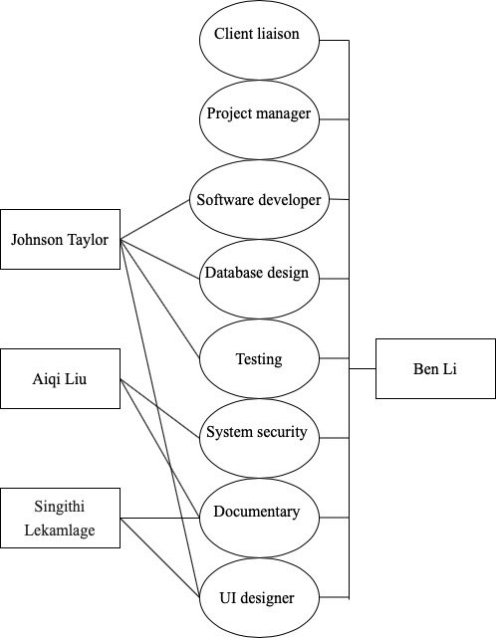
Figure - 1
From diagram 2, the team project manager and client liaison will work with stakeholders form external groups and responses to deliver updated information for each group members.

Project Responsibilities

The list of roles needed for interface project is show in diagram 2 which includes: client liaison, project manager, software developer, database designer, testing, system security, documentary, UI designer. The list of responsibilities that related to each group member will be based on the diagram 2. The project responsibilities table shows below:

Name | Roles | responsibilities
Ben Li | Team member | Manage project life cycle by using proper management tools, with document recorded and deliver to client within deadline. Then deliver the client requirements to group member and assign them reasonable task for each cycle. Also, response to develop the user interface, database and teste the interface.
Aiqi Liu | Team member | Design the system security method, record project document uses proper project management tools. Contribute the UI design ideas.
Johnson Taylor | Team member | Develop the user interface, data base design and perform the proper testing for the user interface
Singithi Lekamlage | Team member | Keep document for project management and design the user interface for AI system.
Andrew Busch | client | Develop the AI system and review the interface development. Decide the final prototype of interface.
David | Interface user | Give feedback after use interface.
table – 5

Identification of Skill Needs
The skills need for interface project is divide into three main categories which are programming languages, database design and other soft skills. The programming language is used for developing the actual web application, the database designed is used for improve the interface usability durability and flexibility. The soft communication skills are sued for deliver the project in the best way to the customer and client. The list of skill needed for this project is show below:
- Program Language required:
  - HTML
  - CSS
  - Python
  - JavaScript
- Data base knowledge required:
  - CSV
  - Json
- Other skills
  - Documents
  - Project management
  - Communication

Satisfaction of Skill Needs
This skills matrix is mapping the proximately rate of group skills that meets the requirements. Each skill is representing all four members’ knowledge. This skill rate is a team self-analysis based on overall team member aware. The skills matrix is used to have a general idea for use of project in project planning and risk management. Skills matrix shows in table -6 in below:
 | unknown | Basic | Good | Master
HTML |  | O
CSS |  | O
Python |  |  | O
JavaScript | O
CSV |  | O
Json | O
Documents |  |  | O
Project management |  |  | O
Communication |  |  | O
table – 6

Success criteria
The cusses’ criteria show below:
- The web interface should respond the data input not late than 100ms.
- The user should be able to clearly reggeized the number change quickly
- The interface is able to visualize the data on maps
- The interface should be coupling and cohesion
- The interface should be work as individual module
- The interface should be work with AI system with proper port connection.

Standards for work products
The team will be fowling ISO, Griffith University and ACS standers for interface. By doing this, the project manager will ensure all team member aware the standard criterion and git repository will set to private use.

- Project Plaining
  - Work Breakdown Structure
The work breakdown Structure for interface project is shown below:
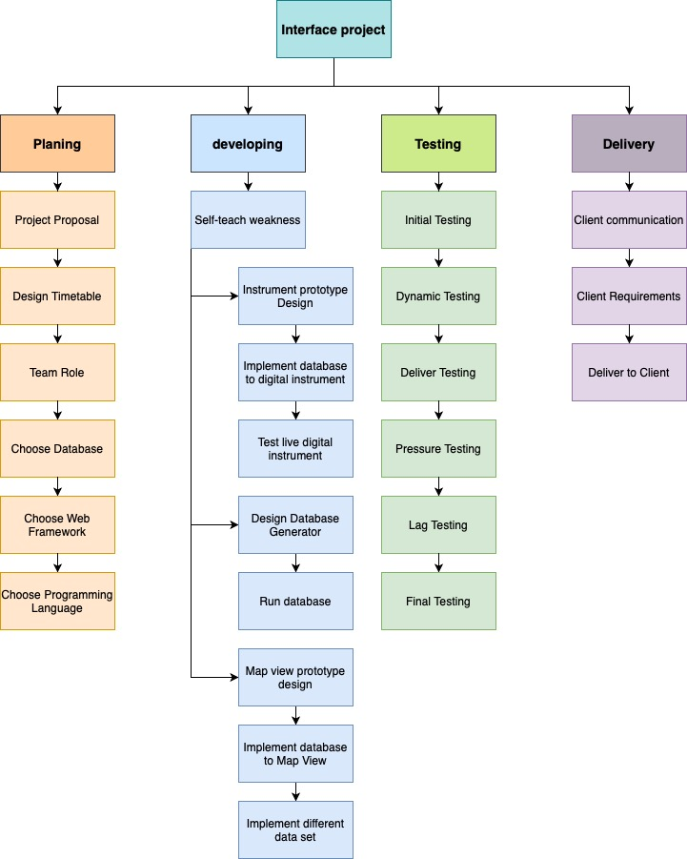
figure -2

  - Gantt Chart
According to work breakdown structure, the list of key tasks involved to Gantt chart is list below, the Gantt chart will design based on list below:
Interface Project
- Planning
  - Initial meeting
  - Project proposal
  - Design timetable
  - Decide team role
  - Choose database
  - Choose web framework
  - Choose Programming Language
  - Second meeting
- Developing
  - Self-teach weakness area
  - Instrument prototype design
  - Implement database to digital instrument
  - Test live digital instrument
  - Design Database
  - Test database
  - Group meeting
  - Develop map view prototypes
  - Implement database to Map view
  - Implement different data set
- Testing
  - Initial testing
  - Lag test
  - Pressure testing
  - Final test
- Delivery
  - Clients communicate
  - Deliver to client

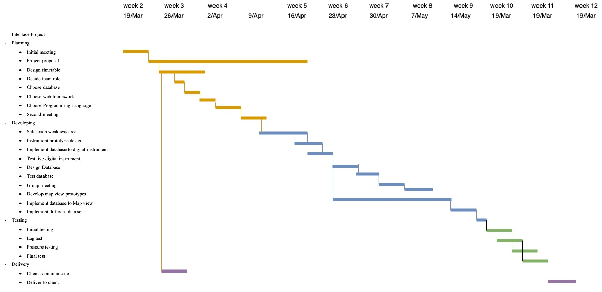

Figure 3

In the figure 3, the Gantt chart shows a time management plan, the longest path of figure 3 is the critical path.

RISK Management

Risk factors identification
The list of potential risk for project will be show blow:
- Failed to complete the project on time
- Failed to deliver project with Map view
- The gauge design is failed to real live data
- Unable to show the detail image in map view
- Unable to change data set in map view
- The UI is unscalable due to different screen size
- Overuse of human resource
- Insecure database
- Unable to fail the client satisfaction
- Unable to deliver proper document for project
- Unable to

Possible risk impact
By analysis the impact of each risk, the risk is calories into two dimensional includes likelihood and time delay. From section 5.1, the number of risk factor will be pass into table 7. The red and yellow colour is the most significant risk that impact the project the most, the green and blue is the less impact risk to interface project. The risk matrix is show below:
Likelihood | Consequences
Likelihood | Insignificant | Minor | Moderate | Major | Catastrophic
Likelihood | 12 Hour delay | 1 day delay | 5 days delay | 15 days delay | 30 days delay
Almost Certain  100% | No.7 | N/A | N/A | N/A | N/A
Likely  20% | No.1 | No.1 | No. 8  No.1 | No. 1 | No.1
Possible  5% | No.1 | No.5 | No.4  No.9 | No.5 | N/A
Unlikely  1% | No.2 | No.5 | No.2 | No.2 | No.9
Rare  0.1% | No.2 | No.6 | No.3 | N/A | N/A
table -7

  - Risk avoiding strategies
From table 6, the team skill compares to the project requirements is below average. Moreover, table – 7 shows the most significant risk will be unable to deliver product to customer. By avoiding these, the self-teaching procedural will become significant at the beginning of the project. Each team developer needs to have deep understanding of HTML, CSS, Python, JavaScript, web structure and database design in order to be start the develop the project. If the team member failed to self-teach the programming skills, the deliver criteria’s must be discussing to client at early stage.
The proper timetable and WBS is also used for avoiding the time management risk for the project. With proper project management tools such as Gantt chart, this can help project manager have better control of the team progress. The one week padding time need to be left for testing the project.

change control management
The git will be the primary tools for manage the changes and updates. The git-hub will be used for team to communicate and update each change for interface development.

Intellectual property
The intellectual property agreements for this project are captured in the Deed of License document.

Agreements

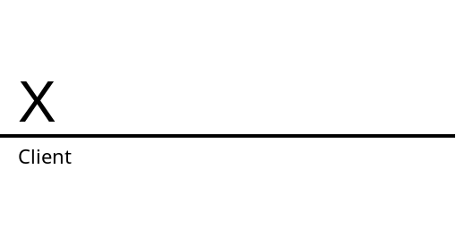

Zhuoheng Li 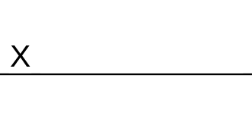
Johnson Taylor
Singithi Lekamlage
Aiqi Liu

